**Learning more about Recursion in python programming**

Kevin Karanja Wachira

Naivasha,2023

**Purpose:**

* Know how recursion works even without using loops in python
* How to use recursion to create a function with recursive process

**Theory:**

Python also accepts function recursion, which means a defined function can call **itself**. Recursion is a common mathematical and programming concept. It means that a function calls itself. This has the benefit of meaning that you can loop through data to reach a result.

In recursion without using loops one must introduce a condition that guide a the recursive process.

All recursive algorithms must obey three important laws: A recursive algorithm must call itself, recursively. A recursive algorithm must have a base case. A recursive algorithm must change its state and move toward the base case.

**Task:**

Given two integers a and b. Determine whether these numbers can be neighboring members of the Fibonacci sequence. The Fibonacci sequence is defined as shown in the attached image:

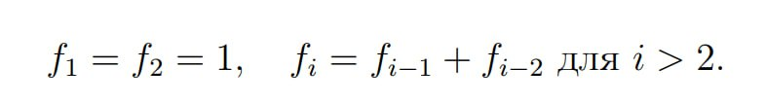

**Solution:**

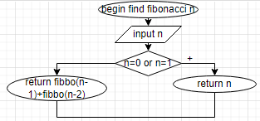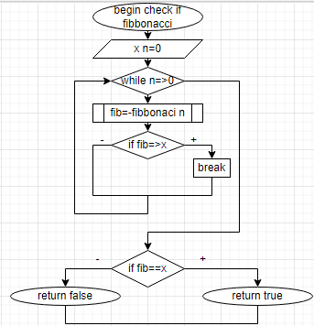

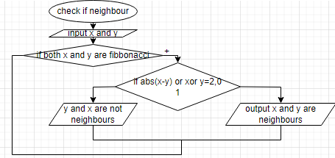

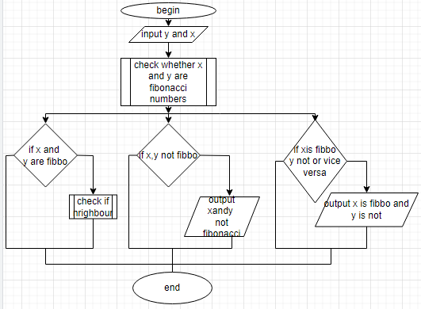

**Code:**

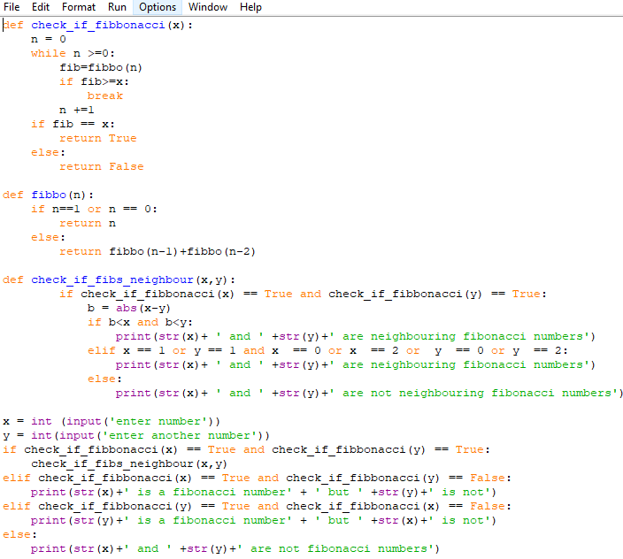

**Test Data:**

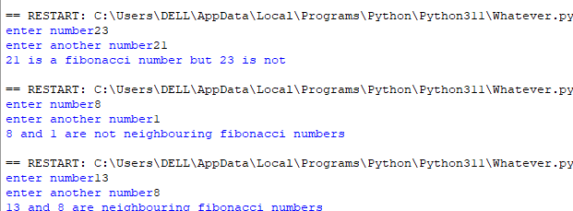

**Conclusion:**

One can work with repetitive process without use of loops